USING RULER AND COMPASS
Pearson Edexcel - Thursday 26 May 2016 - Paper 1 (Non-Calculator) Higher Tier
1.
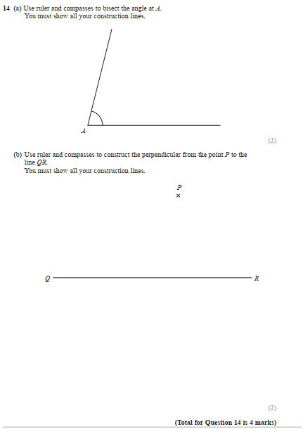

Pearson Edexcel - Monday 6 June 2011 - Paper 3 (Non-Calculator) Higher Tier
2.
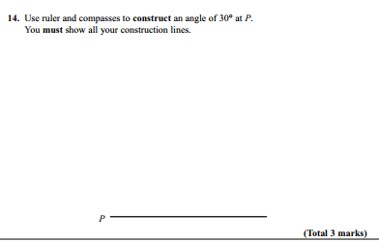

Pearson Edexcel - Tuesday 9 November 2010 - Paper 3 (Non-Calculator) Higher Tier
3.
AQA GSCE – Sample Paper 3 (Calculator) Higher Tier
4.
